**ST 511 Final Project Report**

**Haotian Jia**

**Winter 2021**

***I. Introduction***

In this final project, I got the data set from the **“Kaggle.com”**, and the title of the data set is ***"Medical Cost Personal Datasets"***. Therefore, the proposal of this experiment is to test whether **BMI** (Body mass index, ideally 18.5 to 24.9) and **Insurance charges** are related to different **Regions** (Northeast; Northwest; Southeast; Southwest).

Figure 1 shown below is the box plot of BMI and Regions.

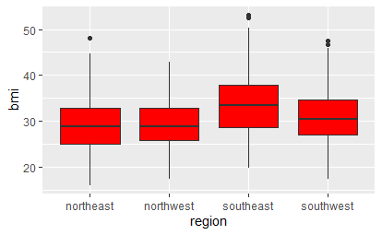

***Figure 1: The relationship between BMI and Regions***

Figure 2 shown below is the box plot of Charges & Regions.

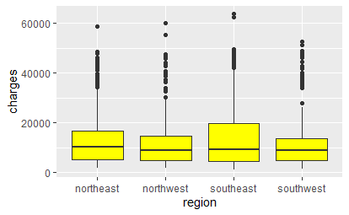

***Figure 2: The relationship between Insurance charges and Regions***

***II. Methods***

Since I want to test whether “BMI (Body mass index)” and “Insurance Charges” are related to different regions, so I prefer to use **“ANOVA”** to test the data because of multiple samples. Therefore, I made the following settings:

1. The null hypothesis is $H_{0} : μ_{1}= μ_{2}= μ_{3}= μ_{4}$;
2. The alternative hypothesis is $H_{A} :at least two population means are different$;

$α=0.05$

***III. Results***

**⑴ BMI:** Based on the data of Figure 3 below, we can get that that the “p-value” is $2.2* {10}^{-16}$. Besides, since $α=0.05$, then we can know that the “p-value” is smaller than $α=0.05$. Therefore, I will **reject the null hypothesis**, which means that there are at least two population means are different.

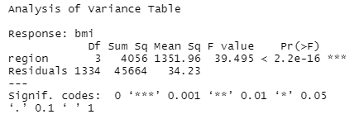

***Figure 3: ANOVA of “bmi ~ region”***

**⑵ Insurance Charges:** In addition, based on the data of Figure 4, I found that the “p-value” is $0.03089$, which is smaller than $α=0.05$. Therefore, I will **reject the null hypothesis**, which means that there are at least two population means are different.

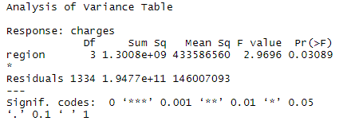

***Figure 4: ANOVA of “charges ~ region”***

***IV. Assessment***

Figure 5 and Figure 6 are showing the residual plots.

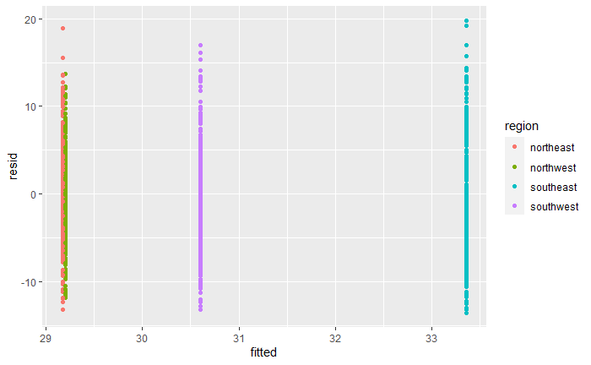

***Figure 5: The residual plot (BMI)***

***Figure 6: The residual plot (Insurance Charges)***

***V. Conclusion***

Based on the analysis of the above four parts, I think the Null hypothesis which I set up is problematic, and it can be intuitively seen that there are many outliers in Figure 2. Therefore, I think I might consider deleting records with outliers in future areas for study or improving this final project by other means.